Painting with water

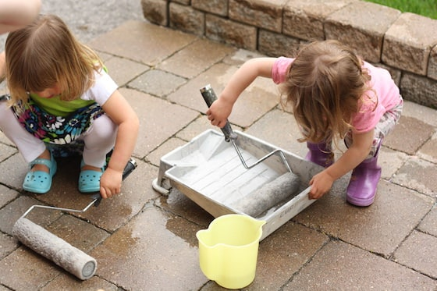
You will need:
A large paint tray
A paint roller
Large paint brushes
A bucket for dipping brushes in

Method:
Take the children outside and let them have fun painting the side of the house or the fence!
Did you know:
The rollers are particularly good for developing gross motor skills and co-ordination because they’re quite heavy when they’re weighted down with water. They can practice letter formation by writing their names with their paintbrushes.
Children can work on their pouring skills as they fill the paint tray with water.
Kids love using grown-up tools, and doing grown-up jobs, and the big brushes and rollers make them feel like they’re doing adult work. It’s not often that kids get to use brushes and rollers this size, and it’s certainly not often that they’re able to paint on a canvas as large as a garage door or the wall of a house, so it’s quite exciting to make art this way.

